Sample Facebook Posts

Federal and state elected leaders are joining together at capitols across the country in a concert of events advancing the unifying message around faith, freedom, civility, and prayer – Join us! #KeepFaithinAmerica #IStandForFaith #LIFFTAmerica

Join millions with one heart and one voice pledging to “Keep Faith in America”
#KeepFaithinAmerica #IStandForFaith #LIFFTAmerica

DAY OF: LIVE TODAY from capitols across the nation – citizens, government and faith leaders are coming together with one voice and pledging to Keep Faith in America! Join the movement here!
#KeepFaithinAmerica #IStandForFaith #LIFFTAmerica

State Specific Event (Illinois as example)

DAY OF: LIVE TODAY from Springfield and capitols across the nation – citizens, government and faith leaders are coming together with one voice and pledging to “Keep Faith in America! Join the movement here!”
#KeepFaithinAmerica #IStandForFaith #LIFFTAmerica

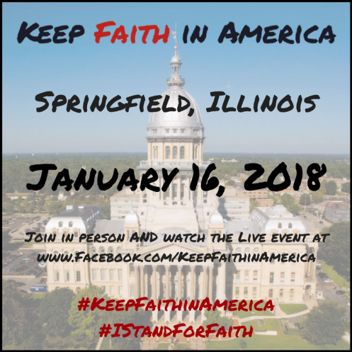

Sample Twitter Posts

Join millions with one heart and one voice pledging to #KeepFaithinAmerica #unite #IStandforFaith #LIFFTAmerica

Uniting as one to #KeepFaithinAmerica

Committed to pray to #KeepFaithinAmerica

